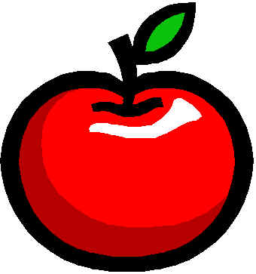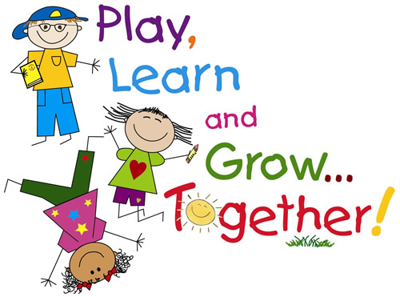

**October Birthdays**

10/1 – Angelina

10/19- Danielle

**Teacher’s Words:**

Dear Parents,

Please practice your address and phone number with your child. There are many children who still have their mobile hanging up in the classroom. If you don’t have it at home then your child does not know it. Before 10/18 all First Quarter skills should be met for Report Card.

Book-its start this month. Reminder to read with your child and then let your child color a picture of the story. Please turn in all 3 pages together and completed before Wednesday 10/31.

Blessings,

Mrs. McDonough

**Important Dates:**

**10/8 – Columbus Day!**

**10/16 – picture re-takes**

**10/19 – End of First Quarter – All skills should be met before this day (vowels, address and phone number, first name in print neatly and colors and shapes).**

**10/21 – Trunk or Treat – donate a bag of candy for an extra punch on your punch card.**

**10/26- Report Cards.**

**10/29-Nov. 1 – Book Fair**

Everett

**Hero of the Week**

**Show and Tell**

Adalee–Friday 10/5

Reminder no toys.

**Art Mom:** Wednesday 10/10 & 10/24 1:00-1:40

**Study Buddies with Mrs. L’s Class**

**We are learning our phone numbers and addressetesting.**

**Bible:** **This week: Matthew 6:9-13 The Lord’s Prayer. This week we will say The Lords Prayer up to “daily bread”.**  We are learning about Enoch☺

**Phonics:** We are starting to add consonants to vowels and make words. We will review blend ladders with T, L, B, and N. This week we will add M and H.

**Handwriting:** Cursive writing continues this week with writing the letters “m” and “h”. We are adding vowels with the letters.

**Math:** We are currently reviewing number recognition and the proper formation of numbers one through twenty. We are writing numbers 5 & 6.

**Social Studies:** This week we will be mailing a letter to ourselves and review what a postal worker does**.** Help your child be excited about the letter they will receive in the mail this week ☺

**Science:** This week we will continue learning about weather. Please ask your child what they know ☺

**Sign Language:** We are reviewing home items.

A Peek at our Week in Kindergarten

The McDonough Weekly

**www.morningsideacademy.com**

Issue 6

Week of Oct. 1-5, 2018