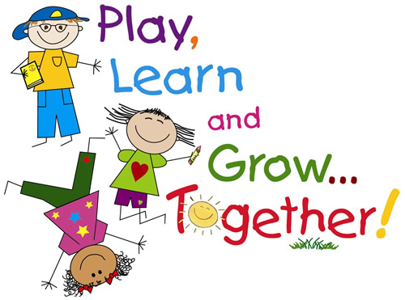

**I hope you enjoy the upcoming Thanksgiving holiday. Focus on your family and all the things you have to be thankful for…we are blessed beyond measure! God is good. I would like to let you know that I am thankful for each one of you! We are focusing on what we are thankful for this month! Ask your child what they are thankful for!**

**Bible:** This week: John 13:34a “A new command I give you: Love one another.”

**Phonics:** This week we will are continuing to learn blends and practice adding an ending letter to make a word. Please practice at home. Reading groups will begin soon. New letter, W and Y.

**Handwriting:**  We are learning connecting letters. New letters are w and y. Practice at home!

**Math:** We are learning the 40’s family and starting addition in math. Practice time to the hour and writing the missing numbers.

**Social Studies:** We are learning about our country and the First Thanksgiving.

**PLEASE PRACTICE AT HOME!!!** Your child needs to be practicing at home on their blends and cursive writing.

**2nd Quarter Skills:** printing their first and last name and recognizing color words (red, orange, yellow, green, blue, purple, brown, black)

**Nov Birthday**

Melina-11th

**Show and Tell**

**Diana Rose- Fri, 18th**

**Important Dates:**

**11/17:** No Chapel

**11/18:** Chapel, 9:00am 1st Grade Musical, Wear Chapel Uniform today! Boys must wear pants now!

**11/22:** Thanksgiving Feast, you may take your child home after the Feast!

(Drop off the dessert donations at the front office in the morning!)

**11/23:** Early Dismissal 11:20 AM. (no new curriculum today, they will not miss anything if you choose to keep them home!)

**11/24 & 11/25:** No school. Thanksgiving break ☺

**11/28:**  Christmas Gift Shop

**Teacher’s Words:**

Dear Parents,

THANK YOU FOR ALL YOU DO FOR OUR CLASS! You are a wonderful group of parents, and I am thankful for each one of you!

The holiday season is already upon us. I know this is a busy time of year, but please don’t lose focus on school work. Things are really going to pick up now. We are about to start reading groups and seatwork. There will be a lot of new things that we will be adding on to our foundation. Please work with your child every night.

In His service,

Ms. Walker

A Peek at our Week in Kindergarten

**www.morningsideacademy.com**

Issue 14

Week of Nov 14-18, 2022

The Walker Weekly