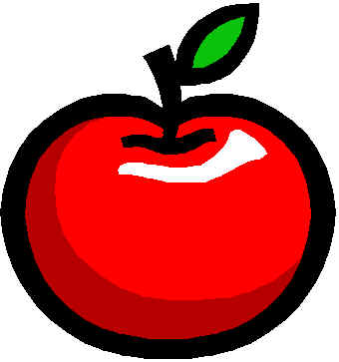

**Waiting for our butterfly to emerge from our chrysalis! It should be soon!**

**Bible:**  This week’s verse is, Ruth 1:16, “Where you go I will go, and where you stay, I will stay. Your people will be my people, and your God my God.”

**Phonics:** This week’s new special sounds: ou in out, ow in owl, ow in bowl

**Reading:** Reading groups will continue this week. We have also begun reading our Science Handbooks out loud. Please, practice reading at home in the reading books that come home (15 minutes each night).

**Handwriting:** This week we are reviewing connecting letters. Practice first and last name in cursive.

**Math:** We are working on the quarter ($.25), addition and subtraction, word problems, counting a combination of coins (nickels and pennies); and time to the hour, half hour, and quarter hour.

**Science:** We are working on our God’s World Science Book. We have started learning about plant life cycles, and we will be sprouting our very own seed.

**YOU NEED TO BE PRACTICING SHOE TYING, FIRST AND LAST NAME IN CURSIVE, AND READING WITH YOUR CHILD AT HOME! IT IS VERY IMPORTANT!**

**April Birthdays**

6th-Jonathan

25th-Matteo

**Show and Tell**

**Mariella, April 29**

**Teacher’s Words:**

Dear Parents,

Please remember to help your children finish out the school year strong. Practice with them daily on their reading!

We will send home information about Kinderfest soon. It is a talent show. Your child will be able to showcase their special talent for all to see! It is a great event that happens at the end of the school year!

There are some more events that will be added to the calendar in the upcoming days. Please be watching for notes to come home detailing all the things that will be happening in our last month of school.

Practice shoe tying! Practice last name!

Thank you for all you do!!

Ms Walker

A Peek at our Week in Kindergarten

**Important Dates:**

**27th: Class NUT Day, “No Uniform Today” Day**

**28th: Kindergarten Violin Chapel Performance**

**\*All violin students must bring their violin**

**to chapel this day\***

**May**

**The last month of school will be super busy! Be watching the folders for lots of important papers with information about Kinderfest, Our End of the Year Party, and so much more…**

**Hold on, don’t quit on me yet! Keep doing the great job you have been doing! Summer is almost here!**

**www.morningsideacademy.com**

Issue 33

Week of April 25-April 29, 2022

The Walker Weekly