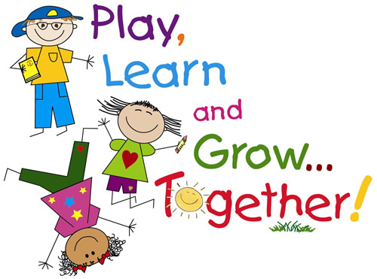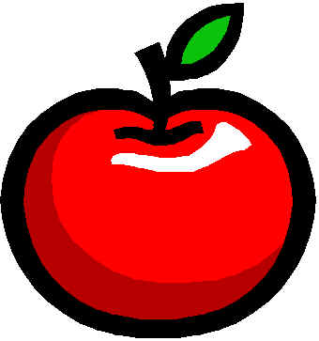

**Student of the Week & Month**

**Show and Tell:**

Lillian Friday 8/25

Reminder: NO Toys!

**Coming Soon**

**Important Dates:**

**9/4: Labor Day – No School**

**9/17: Friends & Family Day – West Campus @ 10:30AM**

**9/19: Fall Pictures**

**9/21: Parent Teacher Meeting**

**9/28: Grandparents Day at MSA!**

**Fun Facts: August is Family Fun Month!**

**Art with Moms:**

**Mystery Readers:**

**Study Buddies with Mrs. L’s Class:**

**Community Helpers: I will call you to set up days/times to come in and share what you do with the class. Thank you.**

**Teacher’s Words:**

Hi Parents,

We had a fun first week of Kindergarten! Please remember to go over the classroom rules with your child and remind him/her often that Jesus loves them. Just a reminder for parents who are bringing in food/supplies; if your child cannot carry something, please drop it off in the school office. Please sign up today for Remind App. Remember to turn in all back to school packet forms before Friday. **No Behavior Reports this week. We will start them next Wednesday.**

Thank you.

God Bless,

Mrs. McDonough

**Upcoming Birthdays**

**Reminder: No cake or cupcakes. Cookies, brownies or rice crispy treats are great after 1:30 P.M.**

**Coming Soon**

**Bible:** Genesis 1:1- In the beginning God created the heaven and the earth.

**Phonics:** This week we will introduce our first short vowel

sounds – “i” as in Indian and “u” as in umbrella.

**Handwriting:** Cursive writing begins this week with writing the letter “i”. Practice holding a pencil properly with only the pointer finger on the top.

**Math:** We are currently reviewing number recognition and the proper formation of numbers one through ten. We are also studying “same and different”, making our own “patterns” and “sorting”.

**Social Studies:** God’s plan for our lives.

**Specials:** We are meeting all of our fantastic “Specials” teachers this week. Mr. Elardo for P.E. and computer, Mrs. Adams for music, Mr. Enyart for violin,

Senora Rojas for Spanish, and Mrs. Daughtry for library.

McDonough Weekly

**www.morningsideacademy.com**

A Peek at our Week in Kindergarten

Issue 1

Week of Aug. 22-25, 2017