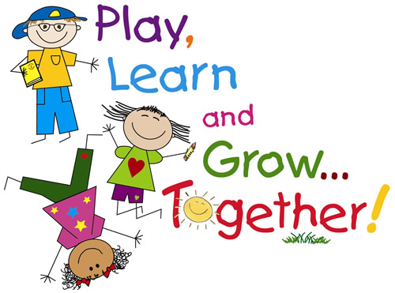

**Important Dates:**

**9/15- Grandparents Day 8:30**

**9/16- Picture Day, Chapel Uniforms**

**9/22- Cookie Dough Fundraiser Begins**

**9/23- Field Trip**

**9/26 – Celebrate Johnny Appleseed Day**

**Bible:** Gen 1:1, “In the beginning God created the heavens and the earth.”

**Phonics:** We finished all our vowels, and we are taking our first test this week. If your child did not do well on the test, consider the Group Tutoring Session that is starting up, this will keep them from falling behind. Info will come home soon. We are starting to learn consonants, and our new letter is “T”. Practice at home!

**Handwriting:** Cursive writing continues this week with writing the letters “o” and “t”. Practice at home please. If you do not practice at home, your child will not improve.

**Math:** We are currently reviewing number recognition and the proper formation of numbers one through three. Practice shape recognition.

**Social Studies:** Community Helpers continues

*Practice at home every day. Use the papers that come home as review sheets. Do not try to go ahead of us!

**First Quarter Skills: Write first name in print**, just as it is written on the practice sheets that have come home. **Recognize shapes**. **Say address and** **phone number from memory**. Practice at home every day! You will know your child has said their address/phone number to us correctly because they will bring home the mobile we made. That is the indication that they have completed this skill.

**Study Buddies with Mrs. T’s Class:**

**We are learning our phone numbers and addresses. Please work on memorizing these at home as well.**

**September Birthdays**

**Show and Tell**

Bryce, Fri 16th

**Teacher’s Words:**

Johnny Appleseed Day will be Mon, Sept 26th. We will be sending out a Google sign up on Remind for snacks to bring to school that day! Thank you so much for your willingness to volunteer to help out our class!

Please work with your child on the proper formation of their first name in print! Some of you have been practicing and it shows! Some of my kiddos really need to work on writing their names correctly.

We are starting testing! Please practice with your child.

Thank you for all you do to make our class the best!

Ms. Walker

A Peek at our Week in Kindergarten

**www.morningsideacademy.com**

Issue 4

Week of Sept. 12-16, 2022

The Walker Weekly